Diagnostic 586220 Harness - Keyboard Dongle Extended Rev. 1

Module Description

# Introduction

The extended Keyboard Dongle is meant to be an extension to existing Diagnostic Harnesses. It prevents the false OK when testing the control ports, while the keyboard PCB is inserted. This is accomplished by analog switches for the feedbacks, that are in common with the joystick signals on the control ports.

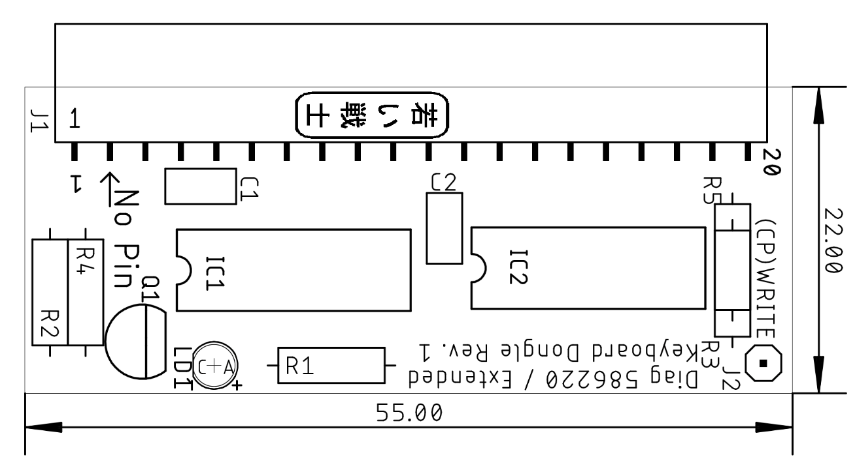

Figure 1: Dimensions of the PCB

The extended Keyboard Dongle for Diagnostic 586220 provides the required feedback connections for testing the C64’s CIA U1, which the keyboard is connected to. An LED serves as an alternative power and operation indicator. It is normally on and switches off while testing the Control Ports.

The Restore key is connected to a dedicated line and is not tested.

What does Extended Keyboard PCB do better than the normal keyboard PCB?

As long as the old keyboard dongle is connected to the keyboard header, the feedbacks bridge the analog switches for testing the control ports. These analog switches are found on the User Port PCB. They are inside the two 4066 ICs there.

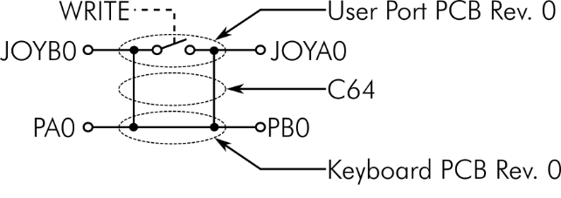

Figure 2: Test situation with the original diagnostic harness

For properly testing the control ports, the old keyboard dongle has to be removed. This way, the test actually requires two passes. Otherwise, the control ports are tested improperly. A broken trace to the control port or a defective port connector would not be detected.

The extended Keyboard Dongle provides switched feedbacks for the signals, that are shared with the joysticks.

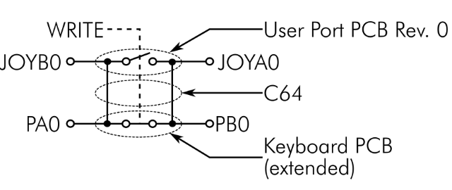

Figure 3: Test situation with the extended Keyboard Dongle

These are PB0↔PA0, PB1↔PA1, PB2↔PA2, PB3↔PA3 and PB4↔PA4. The switches are opened by a (cassette port) WRITE signal going high, which also closes the connection on the user port dongle at the same time. The reason is, that

This WRITE signal is generated via a voltage divider on the user Port Dongle, which is also fed back to the Cassette Port Dongle. It can be found on Pin 5 of the cassette edge connector (on every kind of test harness). An existing harness can be easily modified by soldering a 40cm Dupont cable to the indicated Pin (refer to Figure 4), which is then connected to J2 (one pin) of the extended Keyboard Dongle.

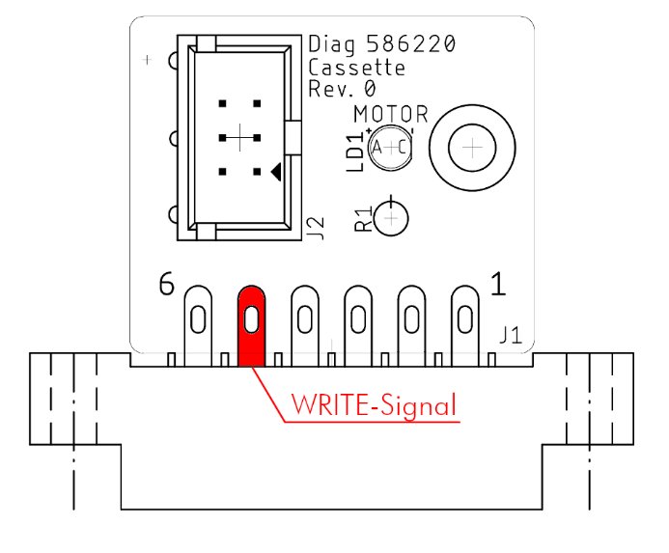

Figure 4: Locating the Write signal

In case this cable is not connected, the extended Keyboard Dongle shows a behavior, that depends on which resistor R3 or R5 is placed. In case R3 is placed, it works like a normal keyboard dongle. The analog switches are closed.

In case R5 is placed, the keyboard feedbacks are open in case J2 is not connected. The test would report keyboard “BAD” (not open, since 3 feedbacks are still present). This might be the preferred behavior, since it indicates that the test did not work properly due to a lack of WRITE signal on this dongle. The LED is switched off, too.

The open state of the switches is indicated by the LED, which is off while testing the control ports (this needs to be observed).

The extended Keyboard Dongle works with all versions of the standard Diagnostic 586220 software. A modification of the software is not required.

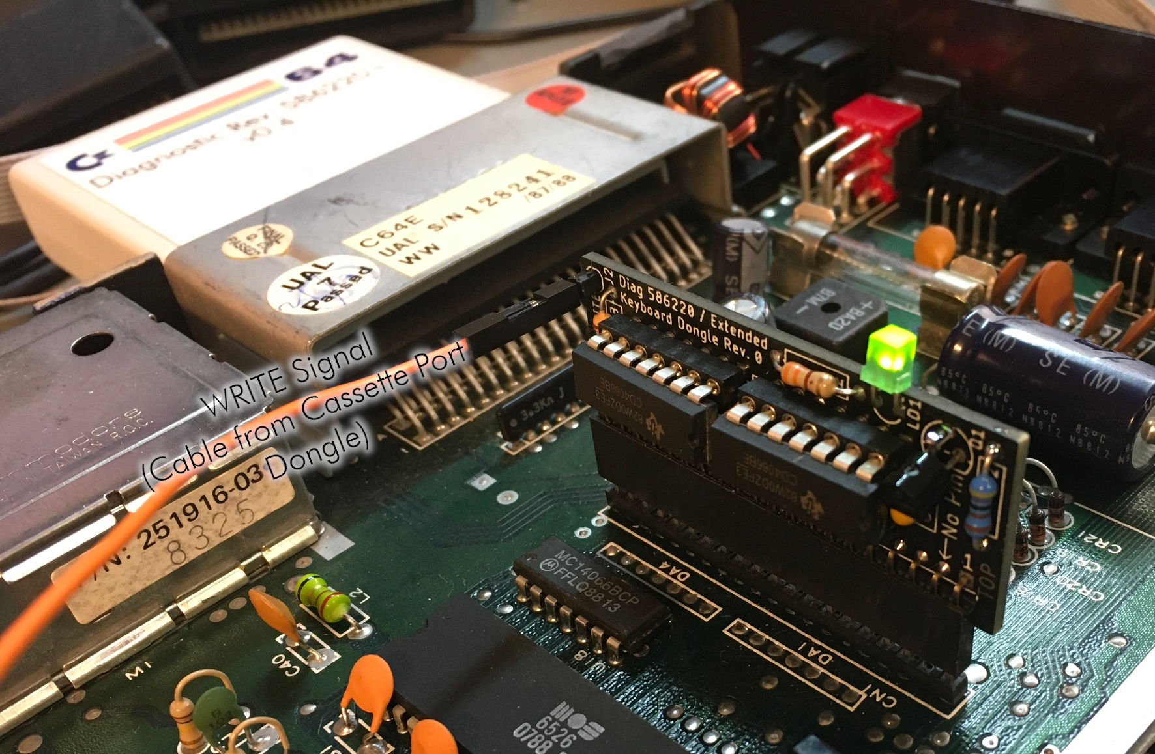

Figure 5: The Extended Keyboard Dongle on an ASSY 250469

# Connections

J1: 20p receptacle (pitch 2.54mm)

|  |  |  |  |  |
| --- | --- | --- | --- | --- |
| **Pin** | **Signal** |  | **Signal** | **Pin** |
| 5 | PB3 | ↔ | PA3 | 17 |
| 6 | PB6 | ↔ | PA6 | 14 |
| 7 | PB5 | ↔ | PA5 | 15 |
| 8 | PB4 | ↔ | PA4 | 16 |
| 9 | PB7 | ↔ | PA7 | 20 |
| 10 | PB2 | ↔ | PA2 | 18 |
| 11 | PB1 | ↔ | PA1 | 19 |
| 12 | PB0 | ↔ | PA0 | 13 |

J2: Single pin (DuPont). Input for the WRITE signal from the Cassette Port (Dongle).

# Revision History

## Rev. 0

Prototype. It requires a modification for working properly (see document 143-6-02-00).

## Rev. 1

* Board revision
* Required modifications (tested on Rev. 0)
* R5 is new for a choice of behavior while J2 (WRITE) is open